**Elevate Labs Cybersecurity-task-2**

**Phishing Email Analysis Report**

**Sample Email Overview:**

**Sender:** service.epayipal@outlook.com

**Subject:** Response required

**Claimed Service:** PayPal

**Screenshot:**

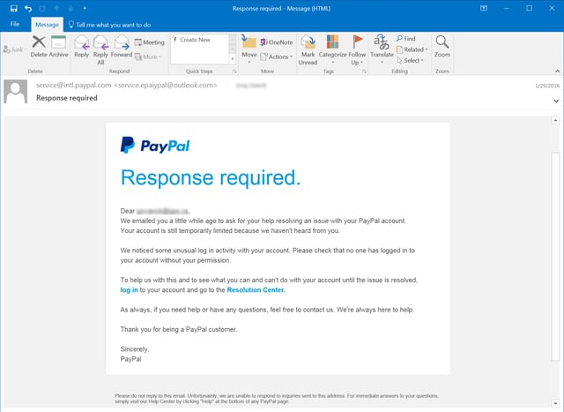

🚩 Phishing Indicators Found

**1. Suspicious Sender**

* Domain used: `@outlook.com`
* Legitimate PayPal domains always use `@paypal.com`.

**2. Urgency and Threats**

* Language like “Response required”, “account temporarily limited” used to cause panic.

**3. Fake Links**

* Hyperlinks text is legitimate (“log in”, “Resolution Center”), but they likely lead to malicious sites.

**4. Impersonal Greeting**

* No actual name used in greeting, often a sign of mass phishing.

**5. No Contact or Signature Verification**

* Lacks digital signature, official contact, or validation footer.

**Tools Used:**

|  |  |
| --- | --- |
| **Tool** | **Purpose** |
| MX Toolbox | Header analysis |
| Virus Total | Checking suspicious links |
| Who is Lookup | Verify sender’s domain |
| Browser Hover | Detect mismatched URLs |

**Conclusion:**

* This email is a clear phishing attempt. Indicators include domain spoofing, fear tactics, generic format, and unverified links.
* Users must avoid clicking on links and report such emails to the official support of the claimed sender.